Social Media Community Engagement
CREATIVE ASSESSMENT

Our social channels
At Tourism Tasmania, our aim is to champion great social experience so that we can connect travellers culturally and emotionally with Tasmania, and nurture them through the customer journey.
As you craft your responses in this assessment, use the statement above to guide you. The attached brand guidelines will also assist in directing the tone of response.

Comment reply
Please draft an ‘on brand’ reply to the following comments.
Example comment | Your crafted reply
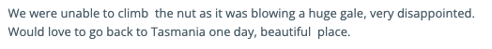

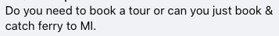

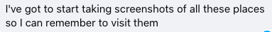

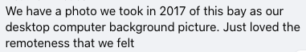

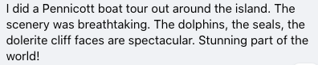

Direct Message reply
Please draft an ‘on brand’ reply to the following direct messages.
Example Direct Message | Your crafted reply
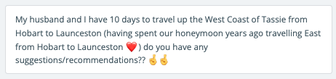

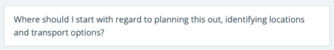

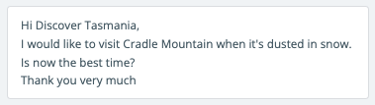

Visual Content Curation
Review the @tasmania tagged content on Instagram and choose three images or videos that you would flag as quality and ‘on brand’ user generated content which we might select to feature on our channels in the future. Please attach links below.

Link to Instagram post | Why you selected this content

Last one, just for fun
From your experience, how do you think emojis are best used in tourism social media marketing and which do you think are most effective?
Additionally, to help us get to know you a little more - which are you favourite emojis to use and why do you love them?

Emojis for tourism social media | Why do you think it’s effective?

Your favourite emojis | Tell us why

